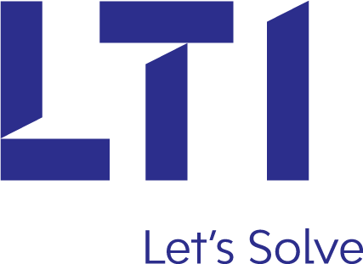



**National Scholarship Portal**

Case Study

**NATIONAL SCHOLARSHIP PORTAL**

**PROBLEM STATEMENT**

Supporting education through scholarships to students of higher learning is an important aspect of government’s effort to assist students at all levels of learning to allow them to afford the basic needs that accrue during their studies. The cost of education has risen drastically over the past few years hindering the families of low-income earners to send their children to school as they can barely afford the cost. Scholarship as defined is a grant or payment made to support a student's education, awarded based on academic or other achievement. There is a lack of awareness amongst the students about the various scholarships that can benefit them tremendously. For a student, finding and applying for a suitable scholarship can prove to be quite a tedious task.

Our portal allows students to connect directly to the government system, wherein they can browse through all the available scholarships and avail these schemes. This system as a part of government schema will ensure that scholarship will be granted to the students by checking various criteria as per the scholarships available.

Various Schemes under our Scholarship Portal includes

* Post Matric Scholarship
* National Merit Scholarship
* Central Scholarship Scheme

Various Modules to be integrated:

1. Student
2. Institute
3. State
4. Ministry

**NATIONAL SCHOLARSHIP PORTAL**

**PROJECT ABSTRACT**

National Scholarship portal is an education related portal. National Scholarship portal is a project developed with the main aim of providing an easy and efficient way for applying and getting a scholarship for students in need of it.

Students will access the web portal by logining to the portal and can apply for the scholarship schemes. The goal of the system is to bring down the workload of the ministry with the increased efficiency and to speed up the process while at the same avoiding duplicated or fake applicants. Government has offered various scholarships based on various criteria like merit,minority and specially for girls to encourage them for Education.

Various Schemes available at our Portal are as follows:

POST MATRIC SCHOLARSHIP

Scholarship Name: Merit-cum-Means based

Objective

The Maharashtra DTE Scholarship gives the opportunity to the students belonging to the backwards categories to study in the government and private colleges after completion of their Class 12th. This scheme not only provides the scholarship to study in technical courses but also gives the chance to apply for undergraduate and postgraduate courses in India.

Eligibility Criteria

Those applicants who are belonging to the economically backward caste/category such as SC/ ST/ OBC or other minorities’ categories are required to check if they come under the eligibility criteria provided by the Directorate of Technical education, Maharashtra Government.

* The candidates applying for the Maharashtra Merit cum Means Scholarship 2017-2018 must have completed 10th and 12th from a recognized board with a minimum of 60% marks in aggregate.
* Maximum two members of a family belonging to the minority category can apply for the scholarship.
* Students applying for the Maharashtra Merit cum Means Scholarship 2017-2018 must have Aadhaar Card enrolled in the State.
* The applicant must produce all the documents prescribed by the state.

**SCHOLARSHIP MEANT FOR GIRLS**

**PRAGATI SCHOLARSHIP**

* ‘One Girl’ per family and it can be extended for Two Girl Child per family where the family income is less than Rs. 8 Lakh /annum (In case of married girl child, the income of parents/ in laws whichever is higher is to be considered).
* The selection of candidate will be made on merit on the basis of qualifying examination to peruse the respective Technical Degree/Diploma course from any of the AICTE approved institution. Amount of scholarship: Tuition Fee of Rs. 30,000/-

**MERIT BASED SCHOLARSHIP**

NTSE (National Talent Search Examination)

Eligibility

* Candidates must be an Indian national.
* A minimum of **60% marks** Class IX is required. SC, ST and PH candidates will need **55% marks** in Class IX.
* Candidate must be studying in a recognized school in their respective State .

**PROCESS FLOW:**

1. **Student Module -**

Student will login through the Portal from the option available on Home Page.If new student has registered then he has to fill the Registration Form.Student will be an entity responsible for providing the information to the institute for verification and for applying for the scholarship according to their eligibility. Three main processes which need to be followed are mentioned below:

1. REGISTRATION:

Any student whose institute comes under state government has to first register under the portal. Information that needs to be filled in the form is as follows:

* + 1. State of Domicile
    2. Name
    3. Gender
    4. Mobile number
    5. Email-id
    6. Institution Code
    7. Aadhar Number
    8. Set Password
    9. Confirm Password.

At the end of the form 2 buttons are provided first will be a Submit button on click of which the institution details will be checked with the Institution Table in the database and the age of applicant will be checked and using Aadhar number the name and mobile number of applicant will be verified.

1. Login:

After registering with the portal, student will then login to check the different schemes made available by the government for students and click on the given link to check the eligibility.

1. Applying for Scheme:

After checking the eligibility, student will click on the Apply option and apply for the scheme by filling the form associated with the Scholarship. Information that needs to be filled:

* Education Details
* Family Details
* Religion
* Caste
* Annual Income
* And Other personal details

Then student will click on submit button, then form will be submitted to the system for eligibility check and if found eligible then form will be forwarded to institute for verification or else form will be rejected.

1. **Institute Module**

Institute will be an entity responsible for verifying the information provided by its students and will forward the approved applications to the State Nodal Officer. Two main processes which need to be followed are mentioned below:

1. REGISTRATION:

Any institute which comes under state government has to first register under the portal. Information that needs to be filled in the form is as follows:

* + 1. State
    2. Institution Name.
    3. Institution Code.
    4. DISE code of Institute
    5. University State
    6. University Name.
    7. Set Password.
    8. Confirm Password.
    9. Institute Establishment Certificate.
    10. University/Board affiliation certificate.

At the end of the form Submit button is provided, when it is clicked the institution registration details will be sent as an application form to the State Nodal Officer. The application will be further forwarded to Ministry after verification by the respective Nodal Officer. If Ministry finds the application to be valid, after approval by the State Nodal Officers, then only Institute Registration will be done by activating the Login credentials of the Institute.

1. LOGIN:

After registering with the portal, institute will then login to verify the details of the applicants. In the homepage of the National Scholarship Portal, there is a login link provided for the institution .Once the institution is verified, it will then be redirected to the next page wherein there will be a button to fetch forms. On click of the button all the students who have applied for the scholarship from that particular institute will be displayed. Institute will verify the basic details and marks entered by the Student are correct or not. If the details are correct and if the student belongs to that particular Institute, then the Institute forwards the application form to State Nodal Officer along with a Bonafide Certificate which is a proof that the Student is registered under that Institution. If details are found Invalid Institute rejects the Application of Student.

1. **STATE NODAL OFFICER MODULE**

State Nodal Officer Login is available on the Homepage of the portal. The application forms of students and the registration forms of Institutes can be viewed and verified by State Nodal Officer. If Officer Clicks on Fetch forms for students then all applications forwarded by Institute are displayed and State Nodal Officer can view Documents associated with each form. If documents are valid State Nodal Officer will forward the application form to Ministry upon their approval or else will reject the application of the student.

When State Nodal Officer clicks on Fetch forms for Institute, then Institute Registration Application forms are displayed. State Officer verifies the uploaded documents and forwards the registration form to the Ministry upon their approval. If documents are found invalid then institute registration application is rejected and will not be forwarded to ministry.

1. **MINISTRY MODULE:**

Ministry is a government department headed by a Minister and a Director. Ministry has declared various Scholarship schemes for Students. Ministry owns the responsibility of granting Scholarships and also can approve the registration of a new Institution under the Online Scholarship Portal.

**Ministry Login:**

Ministry Login option is available for ministry admin (Director) to Login to the Portal. Information related to all the Scholarships is provided on the portal by Ministry. Ministry is provided with options like Fetch Application forms of Students and Fetch Application forms of Institutes. When admin clicks on Fetch forms of students then a list of all the application approved by State Nodal Officer are displayed. Ministry can now decide whether to Grant or Reject the scholarship. If Grant option is selected then Scholarship amount is granted directly into the student’s bank account.

When admin clicks on Fetch forms of Institutes then a list of all the application approved by State Nodal Officer are displayed. Ministry can then Grant registrations to Institutions.

**WORKFLOW**

1. HOMEPAGE IS DISPLAYED

Login

Student Login

UID: _________________

Password: ____________

Forgot Password?

Institute/State/Ministry Login

:

Detailed Description of Portal

HOME ABOUT US CONTACT US NEW REGISTRATION

Helpdesk

Latest Updates

**NATIONAL SCHOLARSHIP PORTAL**

Government of India

2.LOGIN PAGE FOR DIFFERENT USERS

LOGO

NATIONAL SCHOLARSHIP PORTAL

Institute/State/Ministry

Password

FORGET PASSWORD?

LOGIN

3.WHEN STUDENT CLICKS ON REGISTRATION, REGISTRATION FORM IS DISPLAYED

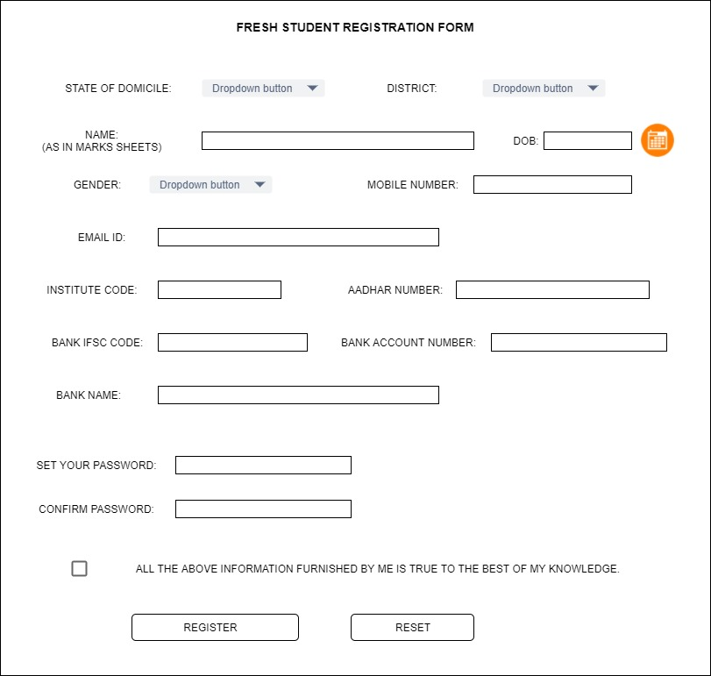

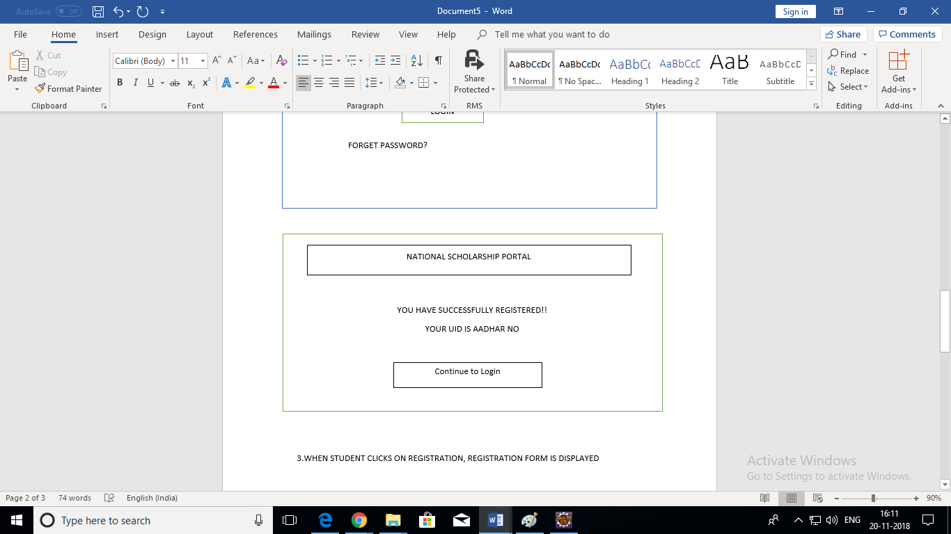

4.STUDENT LOGS IN AND STUDENT HOMEPAGE IS DISPLAYED

LOGO

NATIONAL SCHOLARSHIP PORTAL

HOME About us Contact us

Guidelines

Apply

Scheme Description

Schemes

*

*

*

onclick

MY PROFILE

Check Status

UPDATE

Logout

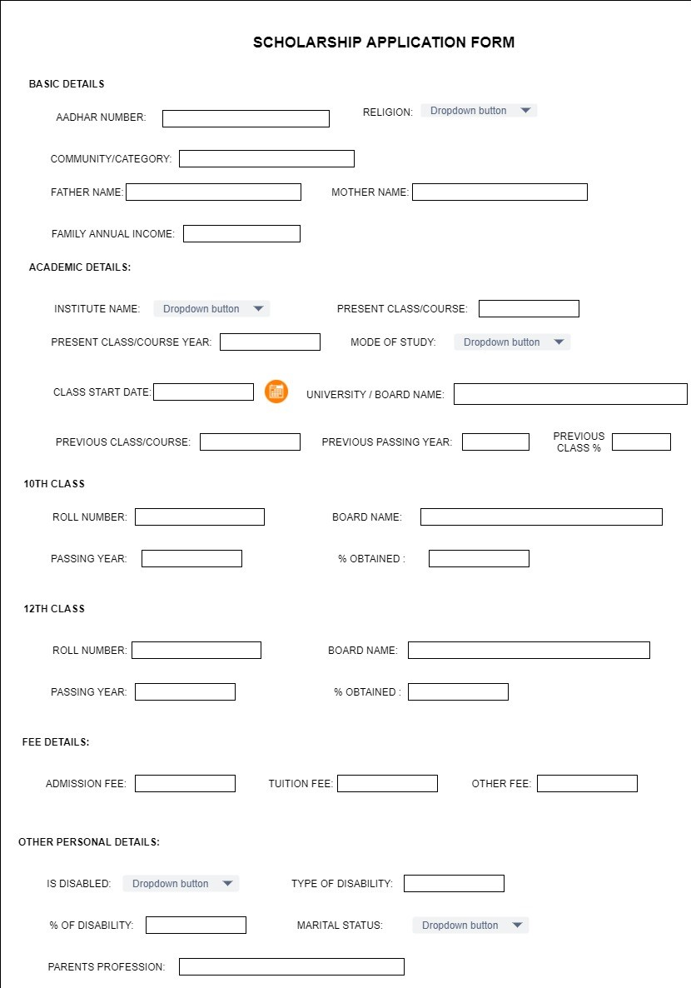5.AFTER CLICKING ON APPLY, SCHOLARSHIP APPLICATION FORM IS DISPLAYED

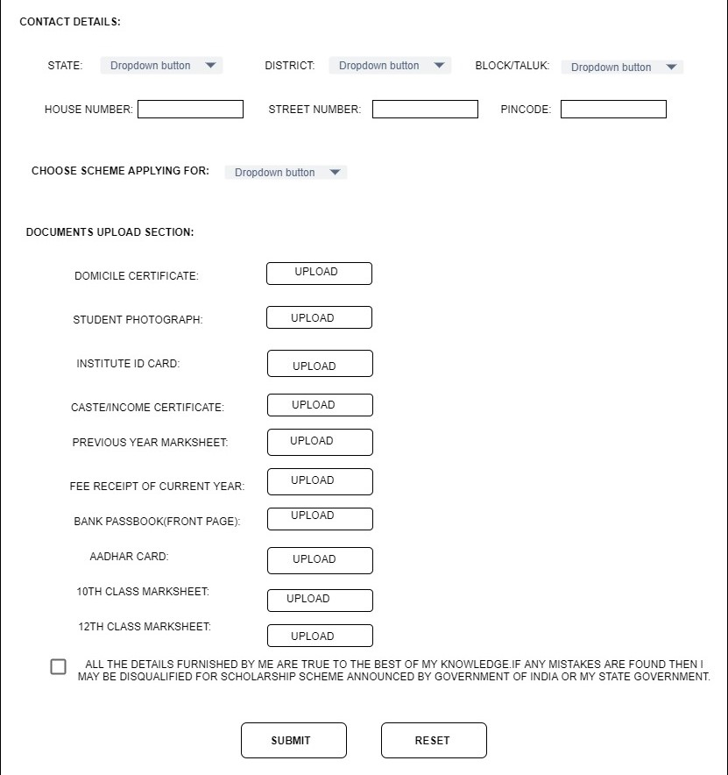

Further process is carried out by institute, State Nodal Officer and Ministry.

6.WHEN INSTITUTE WANTS TO REGISTER, INSTITUTE REGISTRATION FORM IS DISPLAYED

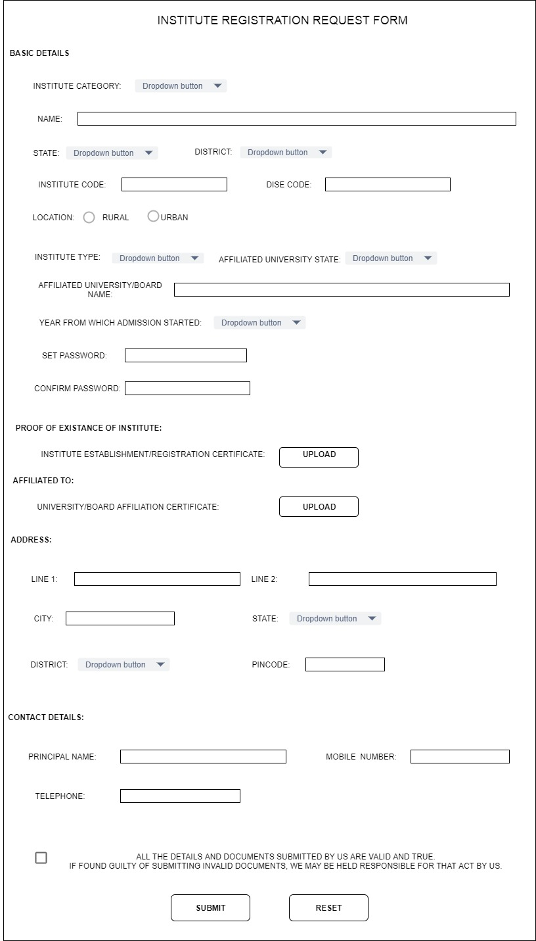

7.PROCESS CARRIED OUT BY INSTITUTE FOR STUDENT APPLICATION VERIFICATION

7.PROCESS CARRIED OUT BY INSTITUTE FOR STUDENT APPLICATION VERIFICATION

NATIONAL SCHOLARSHIP PORTAL

Institute Home Page

Logout

APPLICATION FORM

Institute Name

View Student Application Form

STUDENT APPLICATION

…………………………………………………………

Reject

Cancel 

VIEW

VIEW

VIEW

VERIFY

VIEW

Upload

ATTACH BONAFIDE CERTIFIACTE

8.PROCESS CARRIED OUT BY STATE NODAL OFFICER FOR STUDENT APPLICATION VERIFICATION AND INSTITUTE REGISTRATION VERIFICATION.

1. PROCESS CARRIED OUT BY MINISTRY FOR GRANTING STUDENT SCHOLARSHIP AND APPROVING INSTITUTE REGISTRATION.

LOGOUT

1. 2.

3. 4.

Reject

Cancel

INSTITUTE APPLICATION

………………………………

VERIFY

VIEW

VIEW

View list of Institutes Registered

View Student Application Form

Verify Institute Request

State Nodal Officer Home Page

NATIONAL SCHOLARSHIP PORTAL

hbhb

9.PROCESS CARRIED OUT BY MINISTRY FOR GRANTING STUDENT SCHOLARSHIP AND APPROVING INSTITUTE REGISTRATION.

9.PROCESS CARRIED OUT BY MINISTRY FOR GRANTING STUDENT SCHOLARSHIP AND APPROVING INSTITUTE REGISTRATION.

Ministry Portal

NATIONAL SCHOLARHSIP PORTAL

If Ministry Grants the application, then scholarship will be delivered to the student registered bank account

For institute ministry can grant permission for new Registration or can Reject it

Cancel

Reject

Grant

Particular Student Application Form

Uploaded Forms

1

2

3

4

VIEW

VIEW

VIEW

Student FORM 1

FORM 2

FORM 3

Home

View Student Application Form

View Institutes Registration